Stress Analysis on Chassis

# Introduction

The chassis is a fundamental structure in the tow tractor, supporting all the components such as the motors, battery pack, electrical components, steering, and towing mechanism. Every vehicle chassis must be capable of carrying its own weight while towing additional loads while ensuring smooth movement and stability. The tow tractor chassis consists of a structural framework that supports the entire vehicle body, chassis frames are mostly made of structural members which are used in our design

# Chassis Design

## Design Considerations

When designing the chassis, we focused on two main goals:

* Supporting the weight of the components and towed loads
* Ensure stability and durability during operation

## Chassis Structure and Material Selection

For the chassis structure space frames were used in chassis design and a lightweight and strong materials, so a **steel alloy** was chosen. The selected structural element is **square tube** as it helps distribute weight efficiently while keeping the frame rigid and resistant to bending.

### Cad model

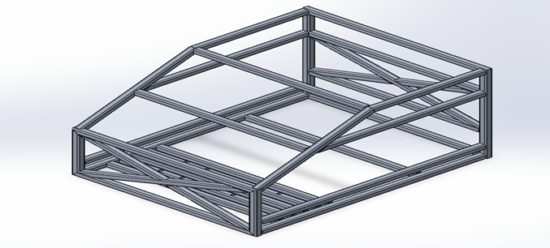

## Loads Acting on Chassis Frame

The chassis of your tow tractor will experience various types of loads during operation, but the ones with high impact will only be considered

* Chassis and components static weights  
  This load represents the constant weight of the chassis itself with all the onboard components. This stress on the frame and must be supported continuously, ensuring the chassis remains rigid and stable.
* Towing loads  
  When the tow tractor is engaged in towing, the additional weight of the towed load puts on an additional continuous stress on the chassis.
* Inertia Loads during acceleration and deceleration  
  These dynamic loads occur when the tow tractor starts moving or comes to a stop. During acceleration, overcoming friction to move the tractor and its load creates inertial stresses. Similarly, deceleration or braking generates forces that can impact chassis integrity.

By analyzing and optimizing for these specific scenarios using Finite Element Analysis the structure is can be ensured that it is robust enough to handle the operational stresses safely and efficiently.

The added loads to all different scenarios are

* Gravity and distributed mass of the components
* A force at the towing mechanism location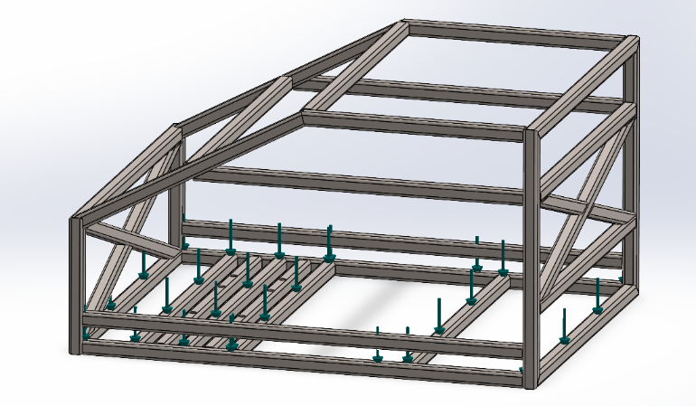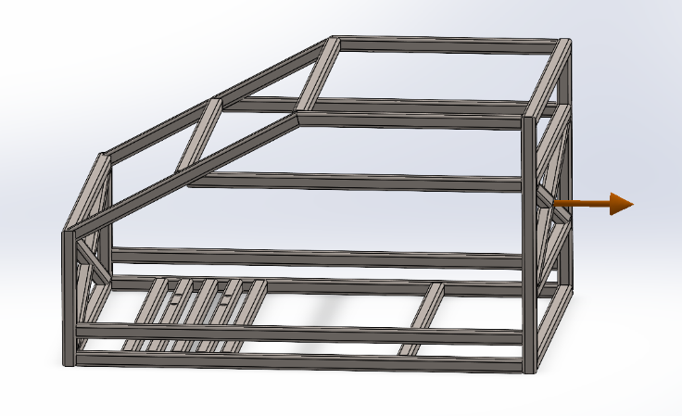

# Finite Element Analysis

## Loading and Boundary Conditions

The loading scenarios discussed before will be simplified to nearly reflect the real-world conditions

Your fixture and loading scenarios seem well thought out, but there's a mix-up in the second point. Here’s a clearer version:

1. 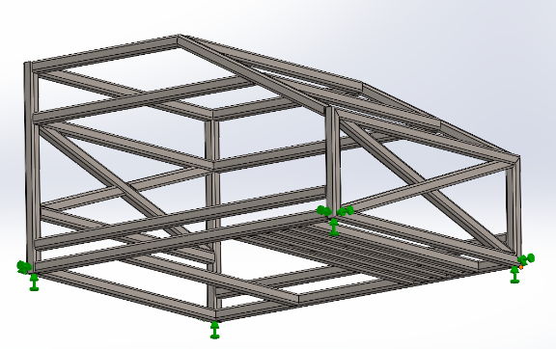**Bottom Corners Fixture**

The chassis is constrained at its bottom corners, simulating support from a rigid surface. This restricts movement at those points while allowing flexibility elsewhere. It provides a more realistic ground contact representation compared to fixing the entire bottom face.

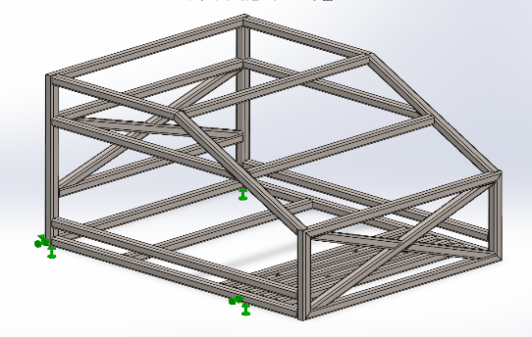

1. **Motors and Back Corners Fixture**

The chassis is fixed at the motor mounts and rear corners, restricting movement at these locations. This setup can represent a scenario where the rear section is anchored while forces act elsewhere.

1. 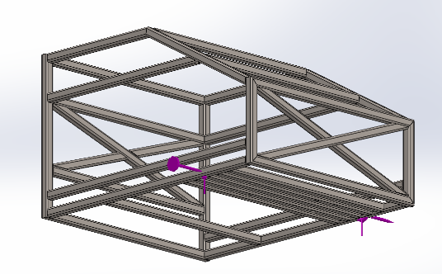**Torque & Forces at Motor Locations**

Driving forces and torques are applied at the motor mounting points to simulate acceleration. These loads represent the propulsion force generated by the motors to move the tow tractor.

All methods introduce simplifications, so it's important to choose the one that best reflects real-world conditions. If needed, a combination of constraints could provide a more realistic boundary condition.

## Results

### Bottom Corners Fixture

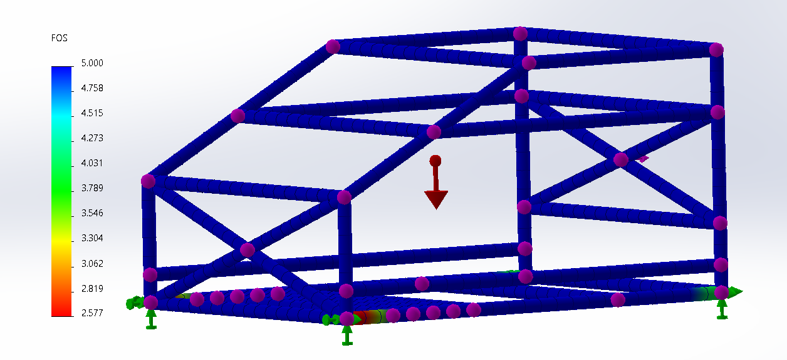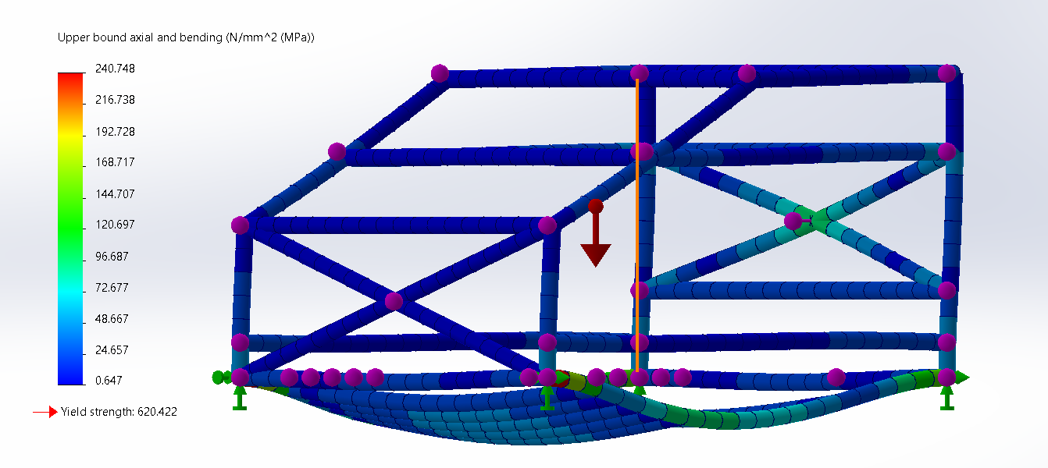

### Motors and Back Corners Fixture

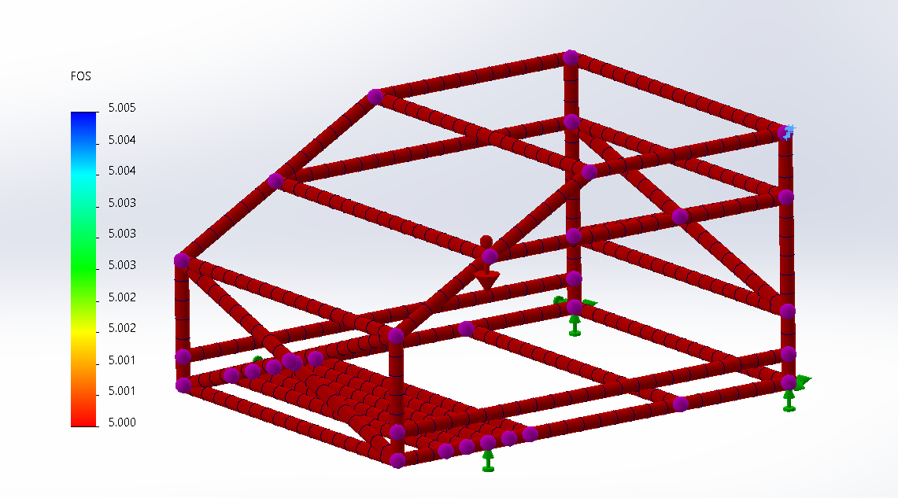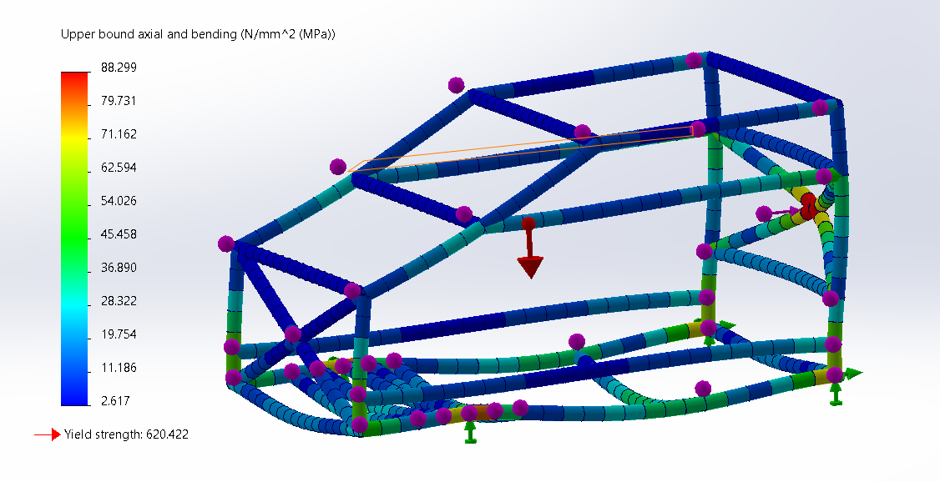

### Torque & Forces at Motor Locations

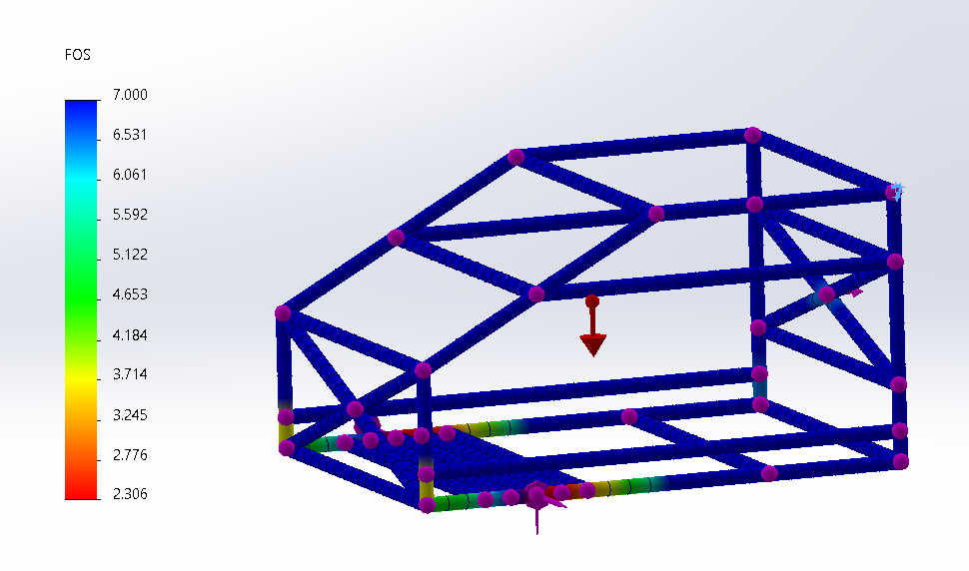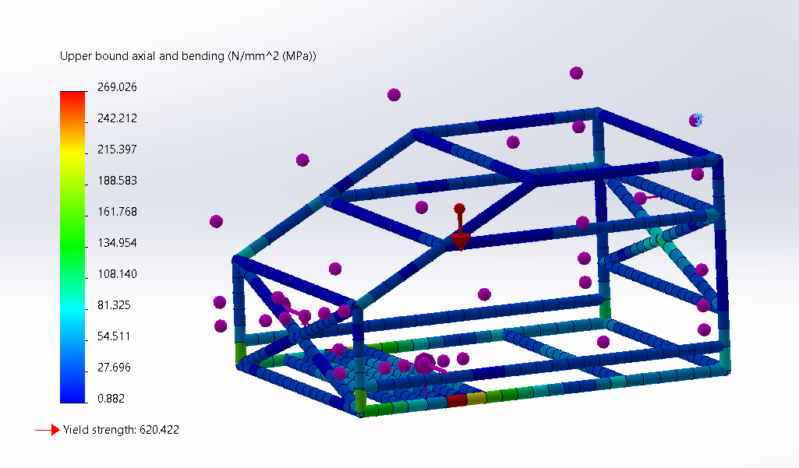

# Conclusion

In all the evaluated scenarios, the results consistently indicated a safe design, with the factor of safety never falling below 2. This ensures that the chassis can withstand expected loads without structural failure. Based on the current analysis, the design meets the required strength and durability criteria, making it suitable for manufacturing and real-world application.